Minimally invasive approach for treatment of displaced intra-articular calcaneal fractures.

Amr Elgazzar, MD; Mahmoud Abouzied, MD and Adel Alhamady, MD.

Corresponding author;
Amr Elgazzar
Assistant professor of orthopedic Surgery
Department of Orthopaedic Surgery, Benha University, Benha- Egypt
e-mail ; dr.amrelgazzar@gmail.com
Mahmoud Abouzaied,MD
e-mail ; abouziedmz83@gmail.com
Lecturer of orthopedic Surgery Department of Orthopaedic Surgery, Benha University, Benha- Egypt

Adel Alhamady,MD
e-mail ; adel_elhammady@hotmail.com
Lecturer of orthopedic Surgery Department of Orthopaedic Surgery, Benha University, Benha- Egypt

Abstract:
Background: Minimally invasive approaches became an alternative to the extensile lateral approach used for treatment of displaced intra-articular calcaneal fractures to reduce the high rates of soft tissue complications. The aim of the study was to evaluate the outcomes of minimally invasive approach for treatment of displaced intra-articular calcaneal fracture using a mini-plate through sinus tarsi approach and percutaneous screws.
Patients & Methods: During the period from January 2015 to June 2016, 69 patients including 58 males and 11 females with intra-articular fracture calcaneus were treated in Benha University and insurance hospitals by minimally invasive approach using a mini-plate and percutaneous screws. The mean age was 30.9 (ranged 15 to 45) years. The affected sides were right in 54 patients and 15 with left side. There were 17 smoker patients, 5 diabetic patients, and no open fractures. The mean preoperative delay was 8.2 (ranged 5 to 11) days. There were 47 patients with intra-articular fracture sander type II and 22 patients with intra-articular fracture Sander type III. The mean follow up period was 36.2 (ranged 28 to 39) months.
Results: Fracture healing occurred after a mean of 9.8 months. The Böhler’s angle improved from a preoperative mean of 5±2 degrees to a mean of 25±4 degrees postoperatively with a mean of 28±4 degrees for the contralateral side. The Gissane angle improved from 147±5 degrees preoperatively to 135±2 degrees postoperatively with a mean of 133±2 degrees for the contralateral side. The median visual analogue scale (VAS) for pain became 1 (range, 0 to 3) postoperatively. The mean hindfoot score of American orthopedic foot and ankle society (AOFAS) became 83±4 postoperatively. Four patients underwent to subtalar arthrodesis during follow up period with only two patients treated from superficial wound infection by intravenous antibiotics.
Conclusion: Treatment of displaced intra-articular calcaneal fractures by minimally invasive sinus tarsi approach with percutaneous cannulated screws is an effective method for achieving articular reduction, early range of motion and preventing wound complications and malalignment.
Level of evidence: level IV, retrospective case series.
Keywords: Intra-articular calcaneal fracture, Sinus tarsi approach, Minimal invasive treatment of calcaneal fracture.

Introduction
Calcaneal fractures account for approximately 2% of all fracture. Intraarticular fractures comprising 60% to 75% of these injuries [1]. These injuries occur predominantly in young patients, which usually have high socioeconomic impact. The treatment of such fractures has a lot of controversies ranging from casting technique to open reduction and internal fixation. There is a consensus that anatomical joint reduction and restoration of the calceneal shape are the major factors that influence prognosis [2]. Open reduction and internal fixation through lateral extensile approach can achieve these goals but the elevated wound complication rates as marginal necrosis and infection renders multiple authors to think about other approaches to limit these complications with preservation of the main goals of as articular congruity and restoring normal calcaneal geometry [3].
The purpose of the study was to evaluate the effectiveness of minimally invasive fixation of intra-articular calcaneal fractures using mini-plate through sinus tarsi approach and percutaneous cannulated screws to achieve the subtalar articular congruity and restoring the calcaneal geometry with avoiding soft tissue complications.

Patients and methods
This study included 69 patients with unilateral intra-articular fracture calcaneus from January 2015 to June 2016. Most patients (58) were males and 11 patients were females. Seventeen patients were smokers. Displaced intra-articular calcaneal fractures with Sanders classification II and III were included in the study. Exclusion criteria included extra-articular fractures and intra-articular fractures with Sanders classification I and IV, patients with peripheral vascular diseases, open fractures, bilateral injuries, ipsilateral associated fractures, and patients whom were unfit for surgery.
The patients were evaluated preoperatively by wrinkles test in which ankle dorsi-flexion and foot eversion was done to notice the wrinkles over the lateral aspect of the ankle. Presence of wrinkles favors surgical intervention. The preoperative waiting days for positive wrinkles test ranged from 5 to 11 days with a mean of 8.2 days.
Lateral x-rays of the ipsilateral hindfoot were obtained preoperatively to determine Böhler’s and Gissane angles together with the contralateral hindfoot to determine the normal Böhler’s and Gissane angles. Anteroposterior x-rays of the feet were obtained to exclude calcaneo-cuboid joint affection. CT scans were obtained in order to determine the Sanders classification type.

Operative Procedures
All patients were operated under spinal anaethesia with lateral decubitus placing the affected limb upwards on a radiolucent operating table. A skin incision of 3-5 cm was done over the sinus tarsi at about 2 cm distal and anterior to the tip of lateral malleolus. Deep dissection and removing the sinus tarsi fat was done to facilitate exposure of posterior facet.
Elevation and reduction of the posterior facet was performed assisted by hindfoot inversion and temporary stabilization with K-wires. Reduction was checked in the lateral and Broden’s views and Gissane angle was evaluated through image intensifier. One 2.4 mm mini-plate was used to stabilize the elevated and reduced posterior facet fragment to the anterior process reducing the angle of Gisanne.
Varus malaligment of the tuberosity fragment was aligned with the calcaneal body using 5mm Schanz screw or 3 mm K-wire in the tuberosity fragment and the reduction was stabilized by insertion of two percutaneous 4.5 mm cannulated screws from the tuberosity fragment directed anteriorly to prevent varus malalignment and to maintain the calcaneal length.
One or two additional cranially directed 4 mm cannulated screws were used to additionally support the posterior facet, to maintain calcaneal height, and to stabilize separated planter fragment of the tuberosity in some cases (Figure 1).
Bone graft was not used for any patient. Closure in layers was done. The foot was protected by below knee slab for two weeks. Sutures were removed after 2 weeks with the removal of the slab. The patients were encouraged to start range of motion after slab removal. Strict non weight bearing lasts for 12 weeks.

a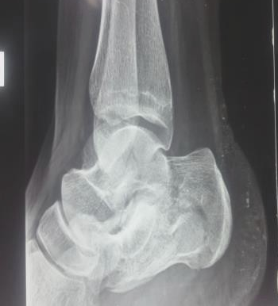 b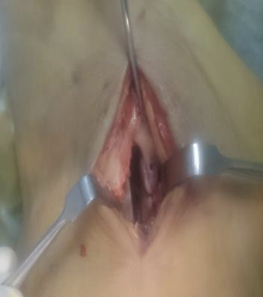 c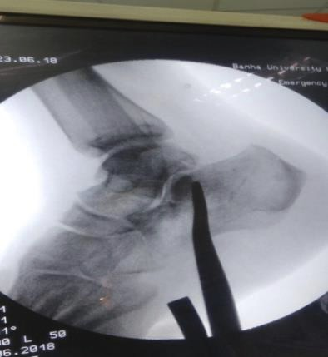 d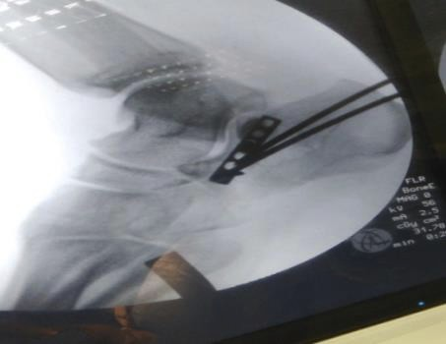
e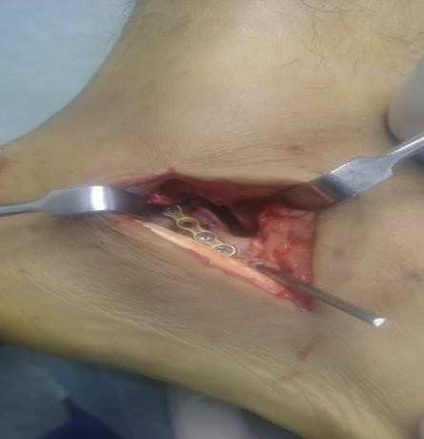 f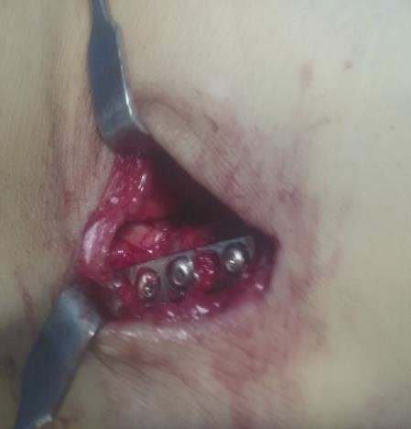 g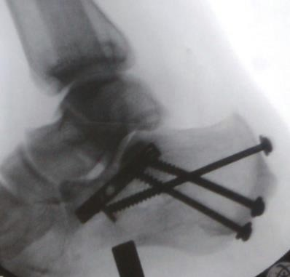
Figure 1: Steps of operative procedures.(A)preoperative lateral x-ray,(B)minimal invasive skin incision,(C)elevation of depressed intra-articular fragment under image control,(D)fixation with plate,(E)preliminary fixation of plate by k-wires,(F)final plate fixation with screws,(G)final fixation under image control.

Radiological postoperative evaluation:
The patients were evaluated radiographically by lateral, anteroposterior and Harris views.The radiographs were obtained in the postoperative day, 2 weeks, 6 weeks, 3 months, 6 months and one year postoperatively. The radiographs were evaluated for reduction of the posterior facet, correction of varus malalingment, radiological union and final measurements of Böhler’s and Gisanne angles. CT scans were obtained at 24 months postoperatively to determine the status of subtalar joint.

Clinical postoperative evaluation:
Clinical evaluation was standardized for all patients at 6 months postoperatively. The patients were evaluated by American orthopedic foot and ankle society (AOFAS) hind foot score. Results more than 90 points were graded as excellent, points >80 were good, points >70 were fair and poor for points < 70 points. Visual analogue scale (VAS) for pain was estimated 6 months postoperatively.
Subtalar range of motion was measured in comparison to the contralateral side. Postoperative evaluation also includes the postoperative hospital stay, complications and the need for further hospital admission.
The mean follow up period was 36.2 (ranged 28 to 39) months.
Data management and statistical analysis were done using SPSS vs.25. (IBM, Armonk, New York, United States). Numerical data were summarized as means and standard deviations or medians and ranges. Categorical data were summarized as numbers and percentages. Böhler’s and Gisanne angles were compared pre and post-operative and post-operative angles were compared to contra-lateral one using paired t-test. All P values were two sided. P values less than 0.05 were considered significant.

Results
There were 69 patients including 58 males and 11 females with a mean age was 30.9 (ranged 15 to 45) years. The affected sides were right in 54 patients and 15 with left side. There were 17 smoker patients, 5 diabetic patients, and no open fractures. The mean preoperative delay was 8 ±2 (ranged 5 to 11) days. There were 47 patients with intra-articular fracture sander type II and 22 patients with intra-articular fracture Sander type III. The mean postoperative hospital stay was 2.1 (ranged 1 to 3) days. The mean follow up period was 36.2 (ranged 28 to 39) months.
Significant improvement of Böhler’s angle was noticed as the mean preoperative Böhler’s angle was 5 ±2 and became 25 ±4 postoperatively. The mean contra lateral Böhler’s angle was 28 ±4 which is insignificant in comparison with the final postoperative Böhler’s angle: (Table 1, 2), (Figure 2).

Table (1) Preoperative and postoperative Böhler’s angles
Böhler’s angle |  |  | P value
Pre-operative | Mean ±SD | 5 ±2 | <0.001
Post-operative | Mean ±SD | 25 ±4
Paired t test was used

Table (2) Final and contralateral Böhler’s angles
Böhler’s angle |  |  | P value
Post-operative | Mean ±SD | 25 ±4 | <0.001
Contralateral | Mean ±SD | 28 ±4
Paired t test was used

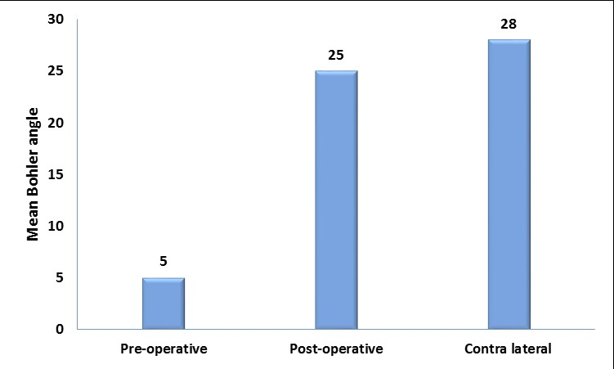
Figure (2): Preoperative and postoperative and contralateral Böhler’s angles

Significant reduction of the Gisanne angle was achieved postoperatively with mean preoperative angle was 147±5 and the mean postoperative became 135 ±2. The mean contra lateral Gisanne was133 ±2: (Table 3,4), (Figure 3).

Table (3) preoperative and postoperative Gissane angle
Gisanne angle |  |  | P value
Pre-operative | Mean ±SD | 147 ±5 | <0.001
Post-operative | Mean ±SD | 135 ±2
Paired t test was used

Table (4): final and contralateral Gissane angle
Gisanne angle |  |  | P value
Post-operative | Mean ±SD | 135 ±2 | <0.001
Contralateral | Mean ±SD | 133 ±2
Paired t test was used

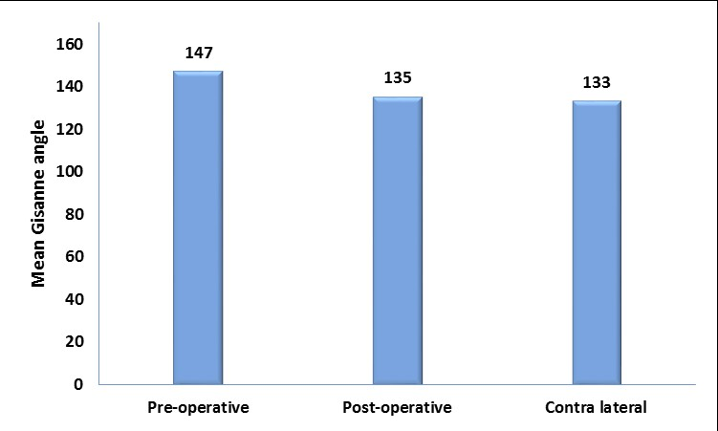
Figure (3) preoperative, postoperative and contralateral Gissane angle

The final results of AOFAS hind foot score were excellent in 16% of the patients, good in 60% of patients and fair in 24 % of the patients with no poor results. The mean AOFAS hindfoot score was 83±4 at 6 months postoperatively. The median for postoperative VAS for pain was 1 (range, 0 to3).
Excellent subtalar joint motion was found in 51 patients (normal range or less than 25 % restriction with comparison with the contralateral healthy side). Good range (25-50% restriction) was found in the rest of the patients with no poor results with marked restriction. All patients had normal ankle range of motion.
Minimal complications were detected in the form of superficial wound infection in 2 patients and treated with antibiotic administration and daily dressing. No surgical debridement was needed. Recovery was achieved within 10 days in one patient and in 2 weeks in the other one.
Further hospital admission was needed in 9 patients. Hardware removal was done due to prominent posterior heel screws in 5 patients. Subtalar arthrodesis was done in only 4 patients during the follow up period due to development of subtalar arthritis which is not proved in CT scans collected for the rest of the patients at 24 months postoperatively. .

Discussion
Conservative management of intra-articular calcaneal fractures is associated with poor outcome due to the resultant complications. Complications of calcaneal fractures fall into four main categories including; surgical wound complications, subtalar arthritis, malalignment, and subtalar joint stiffness [2].
Open reduction and internal fixation by lateral extensile approach is widely used and offers better anatomical reduction but it’s associated with higher rates of wound related complications and infection [1]. Moreover in high risk patients like diabetics, smokers, drug addicts and open fractures the complication rate further increases. The soft tissue dissection and scarring that follows open procedures, further leads to a compromised functional outcome [4].
The target of minimally invasive sins tarsi approach is to overcome the major resultant complications of intra-articular calcaneal fractures by anatomically reducing the posterior facet articular surface which greatly minimizes the progression of subtalar arthritis. This is represented by the significant postoperative improvement of Böhler’s and Gissane angles and their mild deviation from the healthy contralateral side postoperatively. Only 4 patients developed subtalar arthritis during the follow up period which is not proved for the rest of patients at 24 months postoperatively based on CT scans.
Fixation of the articular fragment with mini-plate renders it rigid allowing early range of motion of subtalar joint hence preventing subtalar stiffness. The majority of patients had excellent postoperative subtalar motions and the rest of patients had good results in comparison with the contralateral side. Utilization of percutaneous cannulated screws prevents the tuberosity fragment malalignment. Being a small incision with a minimal dissection, it carries low rates of wound and soft tissue complications. Soft tissue complications were minimal represented by superficial wound infection for 2 patients which was resolved 10 to 15 days with antibiotic administration and daily dressing.
Regarding Böhler’s angle correction, Arastu et al. [5] published a series with a mean correction in Böhler’s angle of 18.7 degrees by only percutaneous method without usage of sinus tarsi approach. Rak et al [6] reported mean Böhler’s angle correction more than 20 degrees achieved in a series of intra-articular fractures treated with locking and non-locking plates. In our study, the radiographic parameters were corrected to near normal at follow-up indicating restoration of the normal calcaneal geometry. Kurozumi et al. [7], also using a sinus tarsi approach, found satisfactory reduction in 88% of patients on follow-up CT.
Schepers et al. [8] reported mean AOFAS hind foot score of 83 with treatment of intra articular calcaneus fracture by closed method, and Nosewicz et al in their study of treatment by open method, observed a mean AOFAS score of 72⁹ .Our series reported the final mean of AOFAS hind foot score as 83.
The present study has the limitations of the lack of a control group and the mid-term duration of follow-up.
Conclusion
Treatment of displaced intra-articular calcaneal fractures by minimal invasive sinus tarsi approach with percutaneous cannulated screws is an effective method for achieving articular reduction, early range of motion and preventing wound complications and malalignment.
References
- Backes M, Schep NWL, Luitse JSK, Goslings C, Schepers T. The effect of postoperative wound infections on functional outcome following intraarticular calcaneal fractures. Arch Orthop Trauma Surg. 2015;135:1045-52.
- Patel NB, Bhavsar NM, Lil NA. Percutaneous fixation of Calcaneum fractures. GCSMC J Med Sci. 2014;3(1):38-41.
- Rammelt S, Amlang M, Barthel S, Gavlik JM, Zwipp H. Percutaneous Treatment of
Less Severe Intraarticular Calcaneal Fractures, Clin Orthop Relat Res. 2010;468:983-90.
- Backes M, Schep NWL, Luitse JSK, Goslings C, Schepers T. The effect of postoperative wound infections on functional outcome following intraarticular calcaneal fractures. Arch Orthop Trauma Surg. 2015;135:1045-52.
- Arastu M, Sheehan B, Buckley R. Minimally invasive reduction and fixation of displaced calcaneal fractures: surgical technique and radiographic analysis. In Orthopaedics (SICOT). 2014;38:539-45.
- Rak V, Ira D, Masek M. Operative treatment of intra articular calcaneal fractures with calcaneal plates and its complications, Indian J Orthop. 2009;43(3):271-80.
- Kurozumi T, Jinno Y, Sato T, et al. Open reduction for intraarticular calcaneal fractures: evaluation using computed tomography. Foot Ankle Int. 2003;24:942 -948.
- Schepers T, Schipper IB, Vogels LM, Ginai AZ. Percutaneous treatment of
displaced intra-articular calcaneal fractures. J Orthop Sci. 2007;12:22-7.
- Nosewicz T, Knupp M, Barg A, Maas M, Bolliger L, Goslings JC, et al. Mini-Open Sinus Tarsi Approach with Percutaneous Screw Fixation of Displaced Calcaneal Fractures: A Prospective Computed Tomography-Based Study. Foot Ankle In. 2012;33:925-33.

